**Record of Ex. No: 1 - Introduction, lettering, 2D Geometrical constructions**

**Date of experiment:** 15.04.2021 **Date of submission:** 29**.**04.2021

**Name:** Kunal Keshan S **Department:** ECE – A **Roll No:** RA2011004010051

**Aim:**

To know the importance of Engineering Graphics, standards, lettering; and to draw simple 2D objects in CAD software.

**Software used:** AutoCAD.

**Procedure:**

**Step 1:** Open the AutoCAD software and type ***UNITS*** in the command line located in the bottom centre of the screen. Set the units to *Millimetres* and select ***OK.***

**Step 2:** Next type ***LIMITS*** on the command line and set the ***Lower left Limit*** as *(0,0)* and the ***Upper Right Limit*** as *(297, 420)*.

**Step 3:** Next select the ***TEXT*** command on the top right side on the home panel or type ***TEXT*** on the command line. Select the point where the text should start and click on it.

**Step 4:** After the selecting the point for the text, mention the ***text height*** to be *10mm* and the ***angle of rotation*** as *0* and type Capital letter from A – Z.

**Step 5:** Repeat **Step 3 – 4** with ***text height*** as *7mm* and for small letters from a – z and ***text height*** *10mm* and *7mm* for Arabic numbers from 0 – 9.

**Step 6:** Next select **LINE** from the home panel or type **LINE** on the command line to draw lines around the text written.

**Step 7:** Using **LINEAR** or by typing **DIMLINEAR** on the command line, give dimensions to the box drawn around the text.

**Step 8:** Using **RECTANG** command on the command line draw a rectangle of *length 170mm* and *width 60mm*. Use **LINE** to draw the required measurements as mentioned in Question 2 figure. Add the required text using **TEXT** command and add dimensions to the title block using **LINEAR**.

**Step 9:** Using the **POLYGON** command draw a triangle, square, pentagon, hexagon of sides *30mm* and a circle of radius of *30mm*. Using the **LINEAR** and **ALIGNED** command the dimensions are given to the polygons and using **TEXT** the corners of the polygons and the centre of the circle are labelled.

**Question 1:** Write (manually or using AutoCAD software) the Capital letter A to Z, small letters a to z, and Arabic numbers 0 to 9 with 0.7mm thick lines and 0.5 mm thick line pencils.

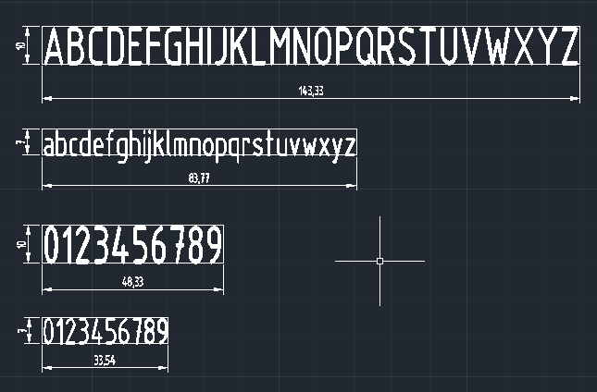

**Question 2:** Draw Margins and Title block in drawing sheet.



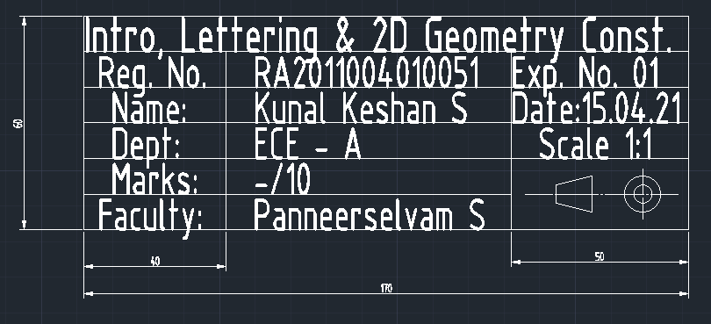

**Questions 3:** Draw the basic 2D geometric entities, each of dimension or side or radius of 30mm (a vertical straight line, a horizontal straight line, an equilateral triangle, a square, a regular pentagon, a regular hexagon, and a circle.) With labels and dimensions.

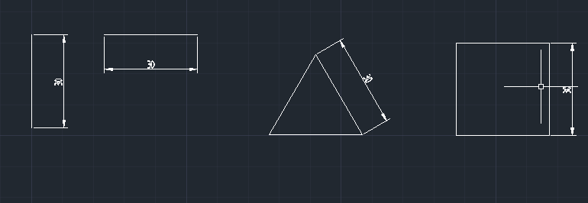

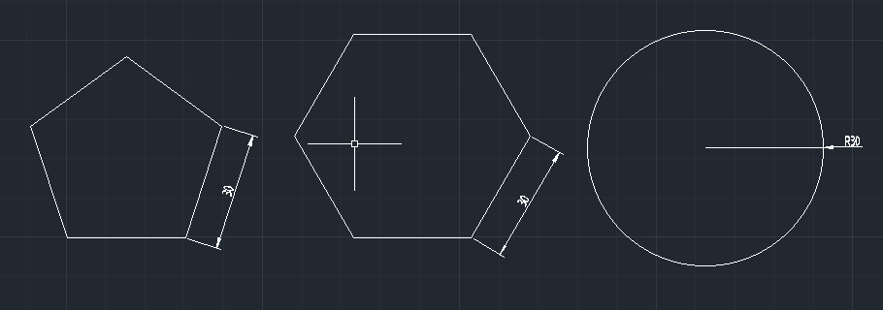

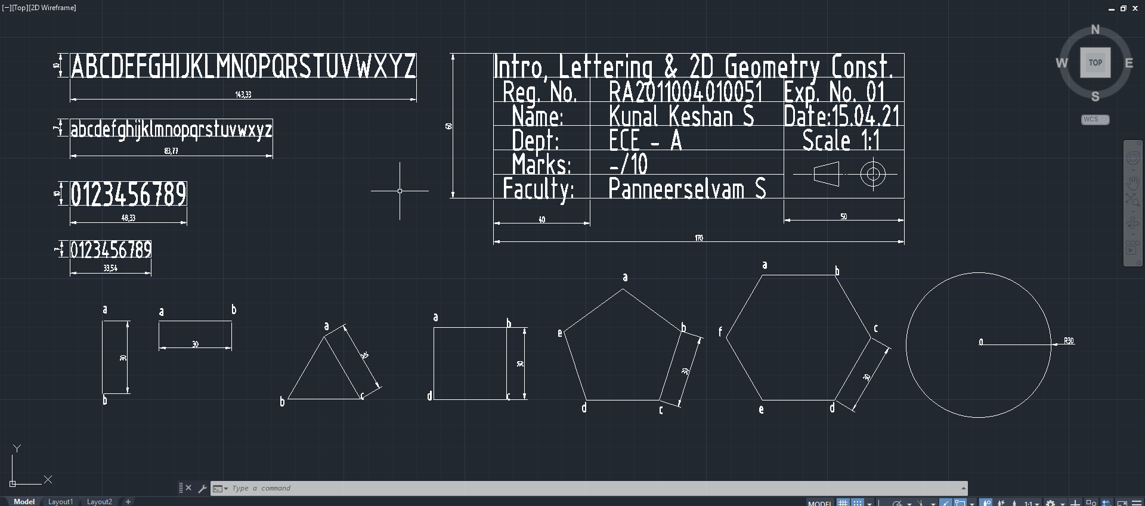**Result:**

